

Directions: Solve the following equations for all values of x.





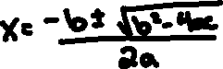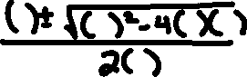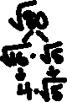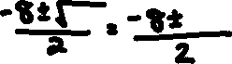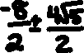

*x* = ____________________

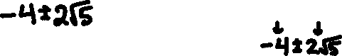



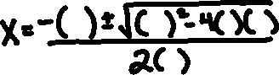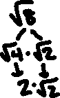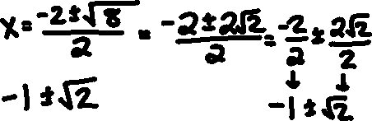

*x* = ____________________





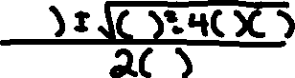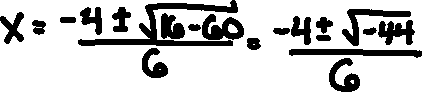

*x* = ____________________

